The core idea between Bootstrap 3 and Bootstrap 4 are the same, we have rows and inside each row we have 12 pieces that we can divide up between different columns, and then we can read and jiggle it around depending on the screen size.

In Bootstrap 4 there is a new extra small (xs) breakpoint, in Bootstrap 3 all sizes less than 768px were considered extra small, but in Bootstrap 4 all screen sizes below 576px are considered as extra small sizes. Any screen sizes equal to 576px and less than 768px are considered as small screen size. Any screen sizes equal to 768px and less than 992px are considered as medium screen size. Any screen equal to 992px and less than 1200px are considered as large screen size. Any screen sizes equal to 1200px and above are considered as extra-large screen size.

So, there are five breakpoints 576px and less, more than or equal to 576px, more than or equal to 768px, more than or equal to 992px and more than or equal to 1200px.

In Bootstrap 3 we used to have classes called *.col-xs-, .col-sm-, .col-md-,* and *.col-lg-.* but in Bootstrap 4 we don’t have any class called *.col-xs-,* instead its called *.col-.* We have an extra large class in Bootstrap 4 called *.col-xl-.*

d-flex which stands for display flex is set to the grid automatically by default. All we need is a div class called container and inside that container class we have a row class and inside that row there is some number of columns.

*<body>*

*<div class= “container”>*

*<h1 class= “text-center display-4”>The Grid</h1>*

*<div class= “row border border-danger”>*

*<h3 class= “col-6 bg-info m-0”>THING 1</h3>*

*<h3 class= “col-6 bg-warning m-0”>THING 2</h3>*

*</div>*

*</div>*

*Output:*

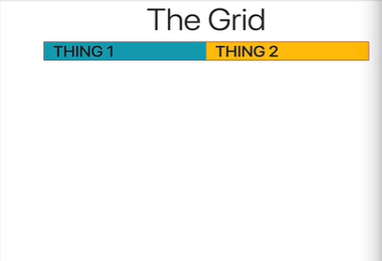

*<body>*

*<div class= “container”>*

*<h1 class= “text-center display-4”>The Grid</h1>*

*<div class= “row border border-danger”>*

*<h3 class= “col-4 bg-info m-0”>THING 1</h3>*

*<h3 class= “col-8 bg-warning m-0”>THING 2</h3>*

*</div>*

*</div>*

*Output:*

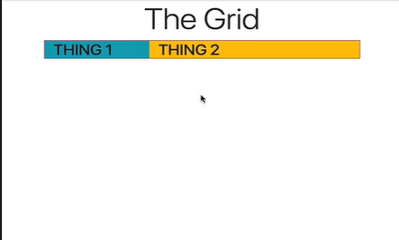

*<body>*

*<div class= “container”>*

*<h1 class= “text-center display-4”>The Grid</h1>*

*<div class= “row border border-danger”>*

*<h3 class= “****col-sm-6*** *bg-info m-0”>THING 1</h3>*

*<h3 class= “****col-sm-6*** *bg-warning m-0”>THING 2</h3>*

*</div>*

*</div>*

*Output:*

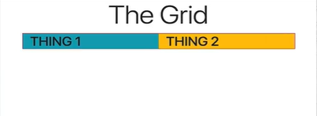

Now we want the THING 2 column to get large, at extra large size and we want THING 1 to shrink down. In that case we have include the class *col-xl-3* for THING 1 and the class *col-xl-9* for THING 2, thus THING 1 taking up 3 columns and THING 2 taking up 9 columns at extra large screen.

*<div class= “container”>*

*<h1 class= “text-center display-4”>The Grid</h1>*

*<div class= “row border border-danger”>*

*<h3 class= “****col-sm-6 col-xl-3*** *bg-info m-0”>THING 1</h3>*

*<h3 class= “****col-sm-6 col-xl-9*** *bg-warning m-0”>THING 2</h3>*

*</div>*

*</div>*

*Output:*

*Small screen*

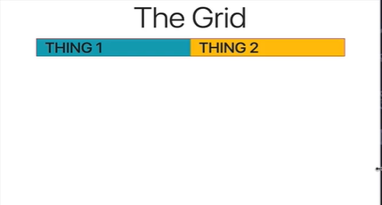

*Extra large screen*



So, at extra large screen THING 1 takes up 3 columns and THING 2 takes up 9 columns.

We can avoid having numbers in and make each items take equal numbers of columns between them when we do not declare any numbers in the classes.

*<div class= “container”>*

*<h1 class= “text-center display-4”>The Grid</h1>*

*<div class= “row border border-danger”>*

*<h3 class= “****col-sm-6 col-xl-3*** *bg-info m-0”>THING 1</h3>*

*<h3 class= “****col-sm-6 col-xl-9*** *bg-warning m-0”>THING 2</h3>*

*</div>*

*<div class= “row”>*

*<div class= “col bg-primary”>THING</div>*

*<div class= “col bg-info”>THING</div>*

*<div class= “col bg-success”>THING</div>*

*</div>*

*</div>*

*Output:*

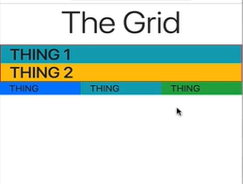

Each THING columns have taken one-third of the total width of the screen. We can also manipulate the number of columns each should take by declaring number on our classes.

We can declare the middle item to take up to 6 columns and the other two items should take the remaining columns in the width.

We can do it by following code.

*<div class= “container”>*

*<h1 class= “text-center display-4”>The Grid</h1>*

*<div class= “row border border-danger”>*

*<h3 class= “****col-sm-6 col-xl-3*** *bg-info m-0”>THING 1</h3>*

*<h3 class= “****col-sm-6 col-xl-9*** *bg-warning m-0”>THING 2</h3>*

*</div>*

*<div class= “row”>*

*<div class= “****col*** *bg-primary”>THING</div>*

*<div class= “****col-6*** *bg-info”>THING</div>*

*<div class= “****col*** *bg-success”>THING</div>*

*</div>*

*</div>*

*Output:*

